Project Planning Phase
Project Planning Template (Product Backlog, Sprint Planning, Stories, Story Points)
Date | 11 September 2026
Project Name | Laptop Request Management System
Maximum Marks | 5 Marks

Product Backlog, Sprint Schedule, and Estimation (4 Marks)
Use the below template to create product backlog and sprint schedule
Sprint | Functional Requirement (Epic) | User Story Number | User Story / Task | Story Points | Priority | Team Members
Sprint-1 | Laptop Request | USN-1 | As an employee, I can submit a laptop request with required details. | 3 | High
Sprint-1 | Request Details | USN-2 | As an employee, I can provide requester and laptop requirement details. | 2 | High
Sprint-1 | Manager Approval | USN-3 | As a manager, I can approve or reject laptop requests. | 3 | High
Sprint-1 | Notifications | USN-4 | As an employee, I can receive notifications about my request status. | 2 | Medium
Sprint-2 | IT Processing | USN-5 | As an IT administrator, I can process approved laptop requests. | 3 | High
Sprint-2 | Laptop Assignment | USN-6 | As an IT administrator, I can assign a laptop and update its status. | 3 | High
Sprint-2 | Tracking & Reporting | USN-7 | As an employee, I can track my request status and view request history. | 2 | Medium
Sprint-2 | Dashboard | USN-8 | As an IT administrator, I can view a dashboard to monitor laptop requests, approval status, and fulfillment status. | 5 | Medium

Project Tracker, Velocity & Burndown Chart (4 Marks)
Sprint | Total Story Points | Duration | Sprint Start Date | Sprint End Date (Planned) | Story Points Completed (as on Planned End Date) | Sprint Release Date (Actual)
Sprint-1 | 10 | 6 Days | 14 Sep 2026 | 19 Sep 2026
Sprint-2 | 13 | 6 Days | 21 Sep 2026 | 26 Sep 2026

Velocity:
Total Story Points = 10 + 13 = 23
Number of Sprints = 2
Average Velocity = Total Story Points / Number of Sprints
Average Velocity = 23 / 2 = 11.5 Story Points per Sprint
The team's average velocity is 11.5 Story Points per Sprint.
Burndown Chart:
A burndown chart is a graphical representation of work left to do versus time. For this project, the planned work starts at 23 story points, reduces to 13 after Sprint 1, and reaches 0 after Sprint 2.
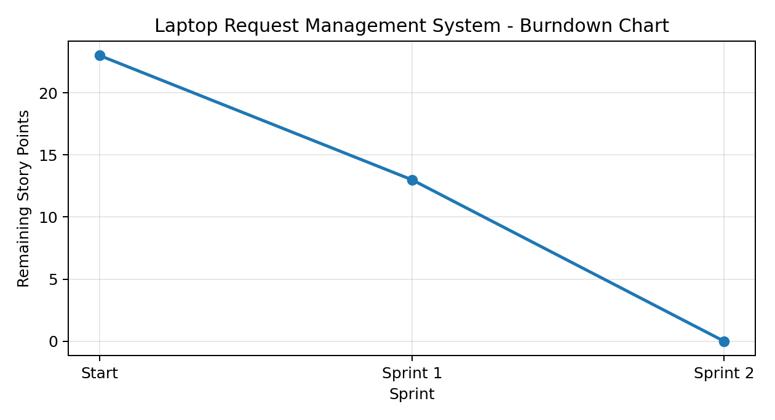
References:
- https://www.visual-paradigm.com/scrum/scrum-burndown-chart/
- https://www.atlassian.com/agile/tutorials/burndown-charts
- https://www.atlassian.com/agile/project-management
- https://www.atlassian.com/agile/tutorials/how-to-do-scrum-with-jira-software
- https://www.atlassian.com/agile/tutorials/epics
- https://www.atlassian.com/agile/tutorials/sprints
- https://www.atlassian.com/agile/project-management/estimation

